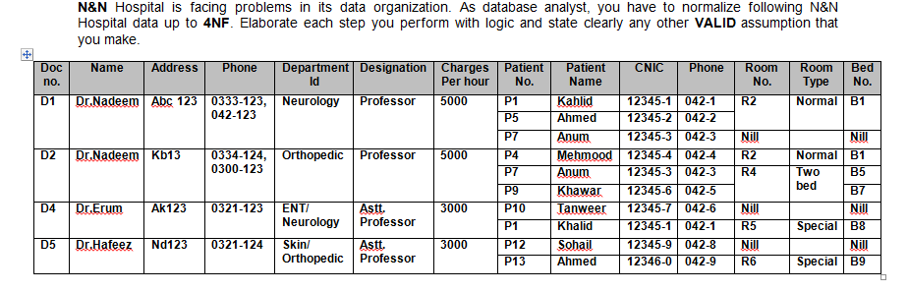

* Normalise the above table upto BCNF.
* Identify and mention the appropriate dependencies in each level of normalization.
* After every normalization level, illustrate the resulting tables with all values
* Elaborate each step clearly and mention any assumption you make to solve the problem.
* Answers can either be submitted as scanned copies of normalization done on paper or as documents where the tables are drawn using tools

1NF

* Should contain simple values.
* Hence normalizing the table into 1NF will give

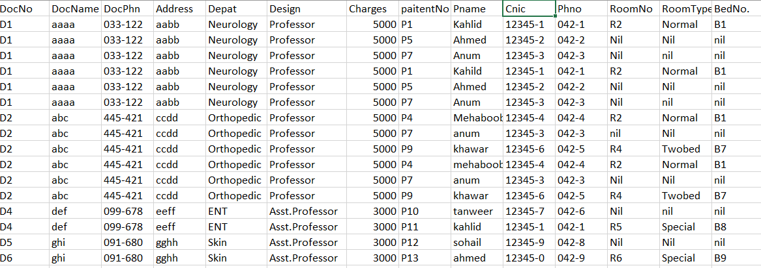

**2NF**

**Candidate Keys** : {DocNo, PaitentNo}

DocName,DocPhn,Address, Depat, Design, Charges 🡪 {PatientNo, DocNo}

PatientName, Phone, Cinic, RoomNo,RoomType, BedNo 🡪(partially dependent) {PatientNo}

To be in 2NF, partial dependency should be eliminated.

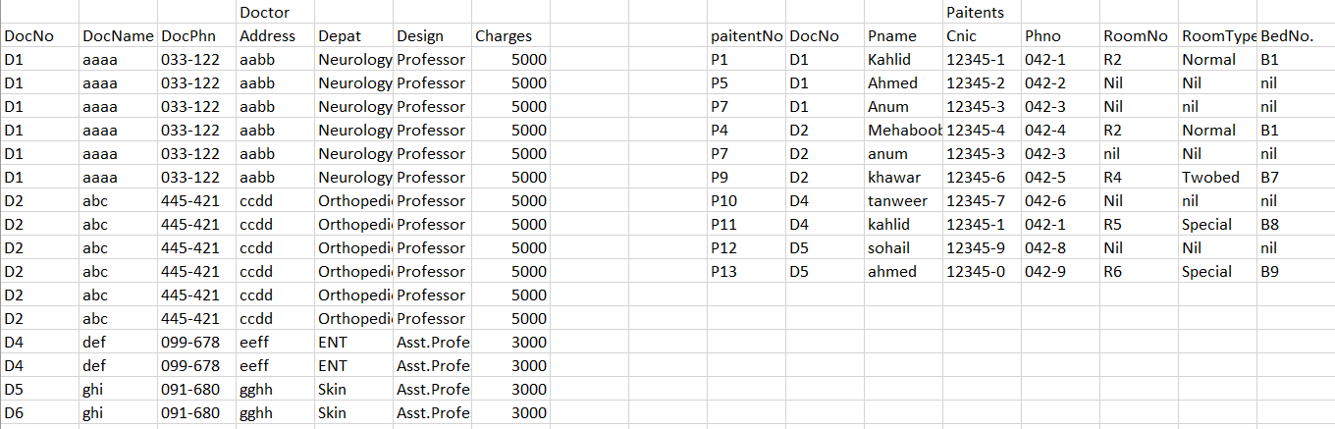

**3NF**

paitentNo 🡪 Pname, Cinic, Phno

BedNo 🡪 RoomNo, RoomType, BedNo

Therefore, PaitentNo 🡪 RoomNo, RoomType, BedNo (This is transitive dependency)

To be in 3NF, transitive dependency should be eliminated.

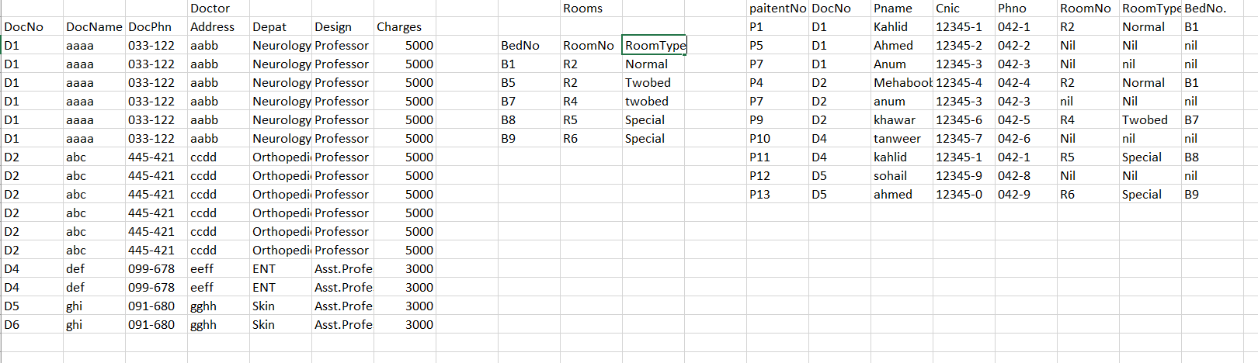

**BCNF**

**Candidate key** : {BedNo}

BedNo 🡪 RoomNo, RoomType

RoomNo 🡪 RoomType (This should not be there)

Hence, final tables

